2025 Season Report for Cedar Rapids and Iowa City Walleye Club, Inc.

Our first CPR tourney on Pool 10 of the Mississippi River at Marquette, Iowa, on June 7th with 6 teams. The event was won by Jeremy and Serenity Geisler with 2nd place to the team of Ethan Trumblee/Matt & Mike Troendle and 3rd place to Mike and Noah Goltz.
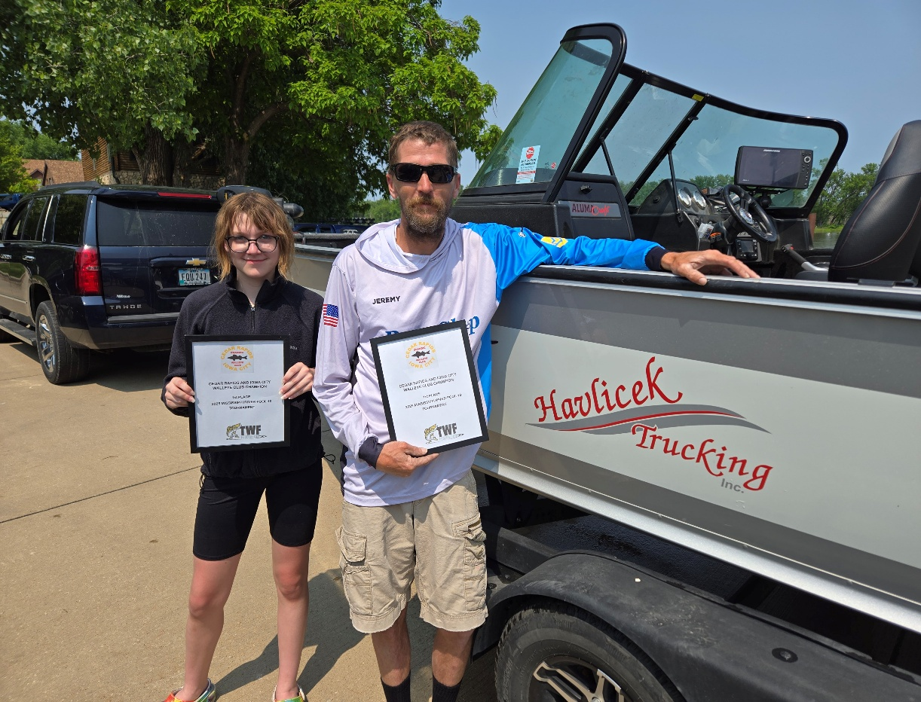

We had our 2nd Tourney of the Year at Coralville Reservoir as a live weigh event. This event was a memorial tourney for former club member and founder, Gary Speicher. We had 7 teams at “The Spike” try to find fish on this very tough body of water. 1st place went to Derek Speicher and AJ Giannetto; 2nd place to Justin Heick and Sarah Speicher; 3rd place to Ethan Trumble and Matt Troendle.
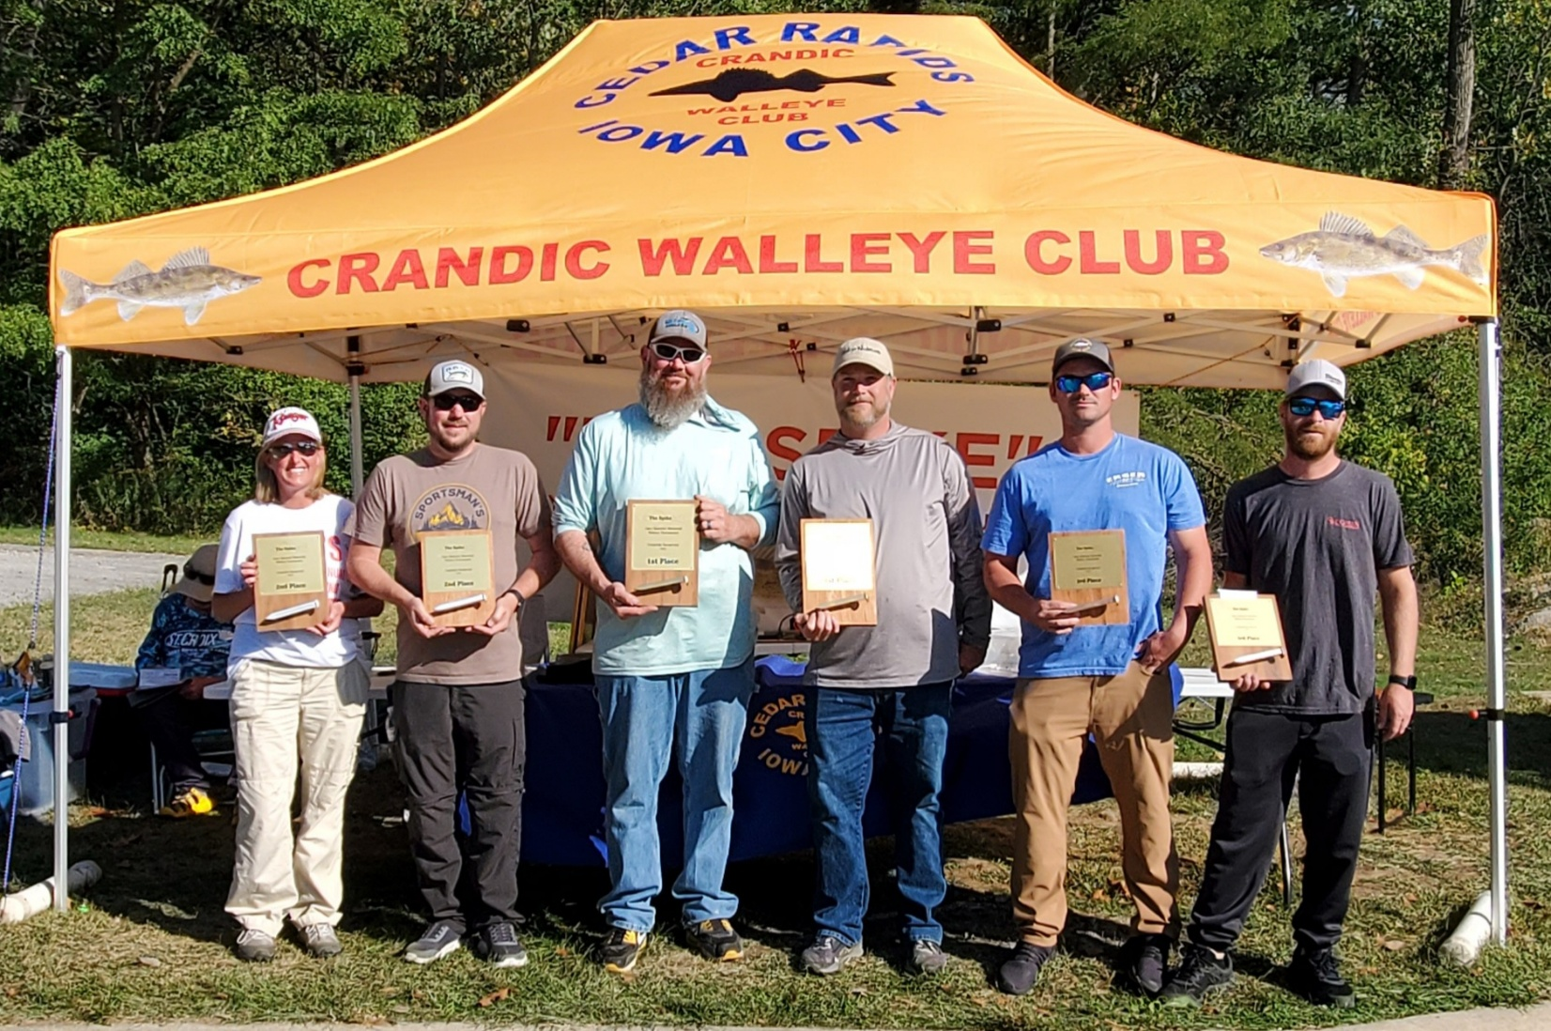

Our final event of the year was a CPR on the Mississippi River at Bellevue, Iowa. We had 5 teams work Pool 13 with the team of Ethan Trumblee, Matt & Mike Troendle finishing 1st. Rick and Adriana “Boo” Drury took 2nd.

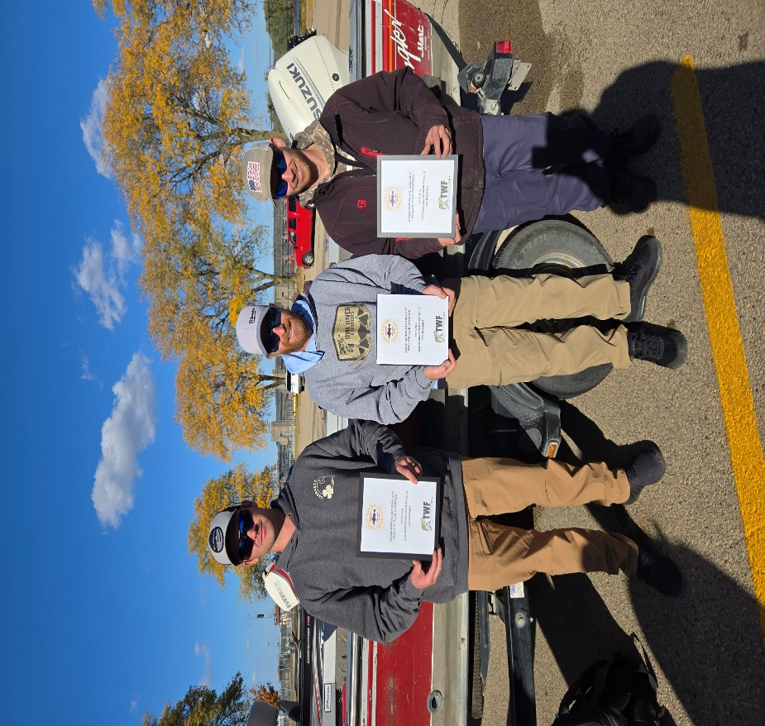
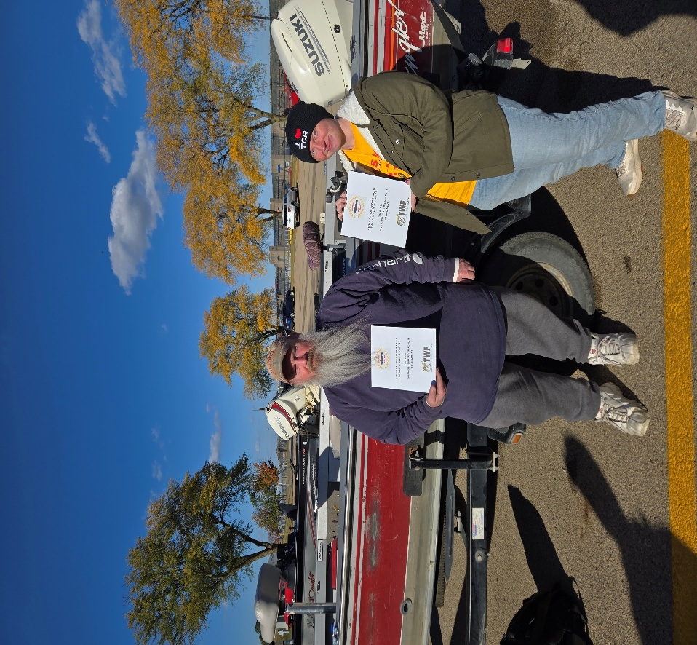

2025 Team of the Year: Ethan Trumblee, Mike Troendle, Matt Troendle

